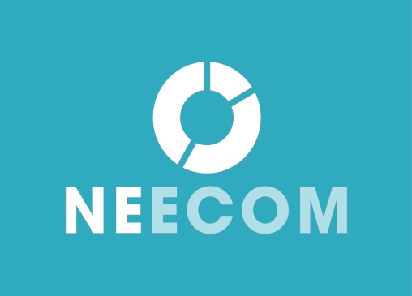

NEECOM Agenda for Day 2 – Thursday, May 7th, 2015

Track 1: EDI-101: An Introduction to Electronic Data Interchange

Track 2: IT Management Skills Development: An Innovative
Full Day Course for Technical & Business Professionals

=======================================================

Track 1: EDI-101 – An Introduction to Electronic Data Interchange
Instructor: Gregg Lanni, Sr. Technical Consultant, Dell Boomi

Course Description:
Are you new to EDI? Does everything seem confusing and difficult to understand? This session will break down each component and give you a greater comprehension of this technology. From its beginnings to the X12 standards, translation software, communications choices and beyond you will learn what a day in the life of an EDI coordinator should be. Your instructor has 20 years of experience working with EDI in manufacturing, translation software programmer, network VAN manager, and as a consultant. In this full-day class, you will receive as much of his experience as possible. Also hear what the future might bring to the industry as well as an opportunity to ask the questions that no one else will answer.

8:00 Registration/Continental Breakfast

8:30 EDI 101
Part One: EDI Fundamentals

10:00 Networking and Refreshment Break

10:15 EDI 101
Part Two: EDI Translation and Business Application

12:00 Lunch

1:00 EDI 101
Part Three: Communication Types and Strategies for Successful EDI Implementation

2:30 Networking and Refreshment Break

2:45 EDI 101

Part Four: Q&A – answering your specific EDI questions

3:30 Adjourn
Track 2:

IT Management Skills Development - An Innovative Full Day Course for Technical and Business Professionals
Instructor: Eric Bloom, CEO, Manager Mechanics, LLC

Two great topics in one training day
‘People in the Morning’ and ‘Productivity in the Afternoon’

8:00 AM – Registration
8:30 AM – Start time

Morning Topic: Manager in the Middle

Client service and vendor management are two sides of the same coin. Sometimes managers provide services to their fellow employees and sometimes they receive services from external vendors. This morning’s session addresses both of these activities.

This topic is designed for individuals and departments that provide services to fellow employees within their company. For example, the Sales, Marketing, Finance and Human Resources groups are clients of the Information Technology (IT) department because IT provides services to these groups.

This topic covers key elements of excellence in vendor management including sourcing, using vendors to build a business case, communicating priorities, the competitive vendor landscape, contracts and negotiating, collaboration and partnership with key vendors, vendor risk assessment, vendor performance issues, transparency and other best practices.

12:00 – 1:00PM Lunch

Afternoon Topic: The Productivity Cocktail ^{tm}

The Productivity Cocktail is a blended mix of seven key business processes, which together, can maximize your personal and team’s productivity. These processes are:

- Smart Delegation
- Meeting Management
- Zone Based Prioritization
- Email Containment
- Process Uniformity
- Conflict Avoidance
- Asset Repurposing
This class provides you with the insights, strategies, and techniques needed to simultaneously increase your personal performance, grow your staff’s abilities, and enhance your team’s efficiency.

